**Table 1. Landscape attributes, diversity and aggregation estimates for epifaunal taxa in nine eelgrass meadows in Barkely Sound**. Fetch was estimated by calculating the distance to nearest land from the eelgrass meadow in 10 degree increments around a centroid point and summing the distances. Diversity at the site level is reported as the number of epifaunal species (30 possible taxa, Table 2) observed in each meadow (γsite) and diversity (Rsite) estimated from extrapolated rarified estimates to 2x minimum following Chao et al (2014)? . Estimates of spatial aggregation (Im) for epifaunal species (mean + se) with significant aggregation across species are indicated in bold (95% CIs do not include 0.5). The proportion of species present in the meadow with significant I values based on Χ2 tests is also given.

|  |  |  |  |  |  |  |
| --- | --- | --- | --- | --- | --- | --- |
| **Site name** | **Site** | **Fetch (km)** | **Diversity**  **(γsite)** | **Aggregation**  **(Im)** | **Diversity**  **Rsite** | **Proportion of species with significant I** |
| Dodger Channel | DC | 32.05 | 17 | 0.47  (0.34 – 0.59) | 18.2  (10.0, 26.4) | 91 |
| Wizard Islet | WI | 50.53 | 18 | 0.41  (0.25 – 0.57) | 19.8  (11.5, 27.8) | 83 |
| Bald Eagle Island | BE | 58.97 | 17 | 0.50  (0.34 – 0.65) | 22.2  (4.78, 39.7) | 90 |
| Ellis Island | EI | 97.17 | 13 | 0.44  (0.28 – 0.60) | 12.3  (7.6, 16.9) | 82 |
| Robbers Passage | RP | 50.55 | 22 | **0.57**  **(0.51 – 0.64)** | 29.4  (19.6, 39.2) | 93 |
| Numukamis Bay | NB | 68.72 | 16 | 0.46  (0.28 – 0.64) | 19.0  (10.7, 27.3) | 88 |
| Crickitt Bay | CB | 24.85 | 14 | 0.53  (0.37 – 0.69) | 14.0  (9.0, 20.0) | 89 |
| Boyson Islands | BI | 51.59 | 17 | 0.38  (0.21 – 0.55) | 17.0  (12.4, 21.6) | 77 |
| Crow Cove | CC | 29.41 | 10 | **0.23**  **(0.03 – 0.40)** | 9.0  (8.0, 10.9) | 67 |

**Table 2: Relative abundance of epifaunal taxa in each meadow.** Numbers indicate the rank of abundances relative to other species observed in that meadow at that time. Species with significant spatial intraspecific aggregation within the meadow, estimated as Morisita’s Index, are indicated in bold. Significance determined by chi-squared tests and P < 0.05. Grazers indicated with *.

|  |  |  |  |  |  |  |  |  |  |  |  |  |  |  |  |  |  |  |  |  |
| --- | --- | --- | --- | --- | --- | --- | --- | --- | --- | --- | --- | --- | --- | --- | --- | --- | --- | --- | --- | --- |
| **Species** | **T** | **DC** | | | **WI** | | | **BE** | **EI** | **RP** | | | **NB** | | | **CB** | | | **BI** | **CC** |
|  |  | **M** | **J** | **A** | **M** | **J** | **A** | **J** | **J** | **M** | **J** | **A** | **M** | **J** | **A** | **M** | **J** | **A** | **J** | **J** |
| ***Crustacean*** |  |  |  |  |  |  |  |  |  |  |  |  |  |  |  |  |  |  |  |  |
| *Caprella spp.*\* | 1 | 1 | **1** | 2 | 9 | **5** | 2 | **1** | **4** | 1 | **1** | 2 | 11 | 11 | 6 | 3 | **6** | 4 | 14 | 4 |
| *Aoroides columbiae\** | 7 | 2 | **2** | 3 | 5 | 11 | 7 | 10 | **6** | 3 | **8** | 5 |  | 7 | 8 |  | **7** | 13 | **8** |  |
| *Pentidotea resecata* | 8 | 4 | **4** | 5 | 7 | **3** | 5 | **3** | 11 | 6 | **9** | 8 | 1 | **3** | 4 | 2 | **5** | 8 | **6** | 5 |
| *Leptochelia dubia* | 9 |  | 16 | 10 | 10 |  |  | 16 |  | 5 | **5** | 7 | 7 | **5** | 12 | 5 | **4** | 2 | **4** | 7 |
| *Photis brevipes\** | 12 | 5 | **3** | 8 | 4 | **7** | 6 | 5 | **7** | 9 | **6** | 9 | 5 | 8 | 3 | 8 | **8** | 5 |  |  |
| *Monocorophium achersicum\** | 13 | 6 | **6** | 6 | 14 | 9 | 14 |  |  |  | **18** |  | 9 |  | 9 | 12 | 9 | 6 | 12 | 9 |
| *Unknown amphipod* | 15 |  | **8** |  | 18 | 15 |  | **2** |  | 10 |  |  |  |  |  | 7 |  |  | **5** | 3 |
| *Pontogeneia rostrata\** | 16 | 9 | **5** |  | 2 |  | 8 | 14 | 12 |  | 15 |  | 8 | 15 | 15 | 10 | 13 |  | 10 |  |
| *Harpacticoid copepod\** | 17 | 12 | 13 | 16 | 11 | 12 | 18 |  |  |  | **11** | 12 | 3 |  | 5 | 13 |  | 10 |  |  |
| *Eogammarus confervicolus* | 18 | 7 | 12 |  | 12 |  | 16 | **8** | 9 |  |  |  | 13 | 12 |  |  |  |  |  |  |
| *Ampithoe spp.\** | 19 | 11 |  | 15 | 13 | 14 | 13 |  |  |  | **16** |  | 14 | 9 | 10 |  |  |  | 15 |  |
| *Balanus spp.* | 21 |  |  | 18 |  |  | 15 |  | 10 |  | **20** | 16 | 16 | 14 | 14 |  |  | 17 |  |  |
| *Cirolana harfordi* | 23 |  | 15 |  | 8 | 13 | 17 | 15 |  |  | **21** |  |  |  |  |  |  |  |  |  |
| *Pugettia richii* | 24 | 13 | 11 | 11 |  |  | 21 |  |  |  |  | 15 |  |  |  |  |  |  |  |  |
| *Pandalidae* | 26 |  |  | 14 |  |  | 20 | 17 |  |  | **17** | 10 |  |  |  |  |  |  |  |  |
| *Pagurus quaylei* | 29 | 14 |  |  | 16 |  | 22 |  |  |  |  |  |  |  |  |  |  |  | 16 |  |
| *Nebalia sp.* | 30 |  |  |  |  |  |  |  |  |  |  |  | 15 |  |  |  |  | 15 |  |  |
|  |  |  |  |  |  |  |  |  |  |  |  |  |  |  |  |  |  |  |  |  |
| ***Gastropod*** |  |  |  |  |  |  |  |  |  |  |  |  |  |  |  |  |  |  |  |  |
| *Phyllaplysia taylori\** | 2 | 3 | 10 | 1 | 15 |  | 9 | 9 | **3** | 4 | **2** | 1 |  | 13 |  |  |  |  |  |  |
| *Mytilus trossulus* | 3 |  | 14 | 7 |  | **1** | 1 | **7** | **1** |  | **3** | 4 | 4 | **2** | 1 | 14 | **1** | 1 | **2** | 1 |
| *Lacuna spp.\** | 14 | 10 | 9 |  | 6 | **2** | 11 | **4** |  | 8 | **12** | 11 | 10 | 10 | 13 | 15 | 10 | 12 | **7** |  |
| *Margarites helicinus\** | 20 |  |  | 12 |  |  | 10 |  |  |  |  |  |  |  |  |  |  |  |  |  |
| *Lottia pelta\** | 22 |  |  | 9 | 17 |  | 19 |  |  |  |  |  |  |  |  | 11 |  |  | 13 |  |
| *Haminoea spp.\** | 27 |  |  |  |  |  |  |  |  |  | **19** | 13 |  |  |  |  |  | 16 |  |  |
| *Alia carinata\** | 28 |  |  |  |  |  |  |  |  |  |  |  |  |  |  |  |  |  | **9** |  |
|  |  |  |  |  |  |  |  |  |  |  |  |  |  |  |  |  |  |  |  |  |
| ***Annelid*** |  |  |  |  |  |  |  |  |  |  |  |  |  |  |  |  |  |  |  |  |
| *Platynereis bicanaliculata* | 4 | 8 | **7** | 4 | 1 | **4** | 4 | **6** | **5** | 2 | **4** | 3 | 6 | **6** | 7 | 4 | 12 | 7 | 11 |  |
| *Janua pagastecheri* | 10 |  |  |  |  | 8 | 3 | 12 |  | 7 | 7 | 6 |  |  |  | 9 |  |  |  |  |
|  |  |  |  |  |  |  |  |  |  |  |  |  |  |  |  |  |  |  |  |  |
| ***Other*** |  |  |  |  |  |  |  |  |  |  |  |  |  |  |  |  |  |  |  |  |
| *Nematode* | 5 |  |  | 13 | 3 | 15 |  |  |  |  | **10** |  | 12 | **1** | 2 |  | **2** | 3 | **1** | 6 |
| *Pycnogonum sp* | 6 |  |  | 17 |  | **6** |  | 13 | **2** |  | 14 | 14 |  |  |  | 1 | 11 | 9 |  | 8 |
| *Halacard mite* | 11 |  |  |  |  | 10 |  | 11 | **8** |  | 13 |  | 2 | **4** |  | 6 | **3** | 11 | **3** | 2 |
| *Nemertea* | 25 |  |  |  |  |  |  |  |  |  |  | 17 | 17 |  | 11 |  |  | 14 |  |  |

**Table 3.** Comparisons of univariate diversity metrics over time using two-way ANOVA with site and sampling time as main effects. *P < 0.01, **P < 0.001

|  |  |  |  |  |  |
| --- | --- | --- | --- | --- | --- |
| **Model** |  | **df** | **Sum Sq** | **Mean Sq** | **F** |
| **Alpha** | **Main Effect** |  |  |  |  |
|  | Site | 4 | 58.57 | 14.64 | **2.99x10-4 |
|  | Time | 2 | 53.50 | 26.75 | **6.47x10-5 |
|  | Site*time | 8 | 122.92 | 15.37 | **1.15x10-5 |
|  | Residuals | 191 | 503.41 | 2.64 |  |
|  |  |  |  |  |  |
| **H’** |  |  |  |  |  |
|  | Site | 4 | 4.41 | 1.10 | **3.48x10-5 |
|  | Time | 2 | 0.16 | 0.08 | 0.60 |
|  | Site*time | 8 | 5.43 | 0.68 | **1.06x10-4 |
|  | Residuals | 191 | 30.65 | 0.16 |  |
|  |  |  |  |  |  |
| **S** |  |  |  |  |  |
|  | Site | 4 | 1.91 | 0.30 | **4.42x10-5 |
|  | Time | 2 | 0.09 | 0.05 | 0.36 |
|  | Site*time | 8 | 1.23 | 0.15 | **9.55x10-4 |
|  | Residuals | 191 | 8.51 | 0.04 |  |
|  |  |  |  |  |  |
| **ENS** |  |  |  |  |  |
|  | Site | 4 | 3.23 | 0.81 | **1.70x10-5 |
|  | Time | 2 | 1.91 | 0.96 | *1.18 x10-3 |
|  | Site*time | 8 | 3.65 | 0.46 | *1.38x10-3 |
|  | Residuals | 191 | 26.18 | 0.14 |  |

**Figures**

**Figure 1**: **A)** Seagrass is found at the coastal margins of Trevor Channel (approximately 200m deep), one of three channels in Barkley Sound that connect freshwater sources in Alberni Inlet and Numukamis Bay with the open Pacific Ocean. Eelgrass meadows sampled during summer 2012 between Alberni Inlet and the Pacific Ocean southwest of Dodger Channel (DC). Five meadows were sampled in May, July and August, while four additional meadows were sampled once in midsummer (asterisk). Site names as in Table 1. BMSC = Bamfield Marine Sciences Centre. B) In each meadow, 16 plots were sampled in a grid, at least two meters from the meadow edge, and X depth.

A)

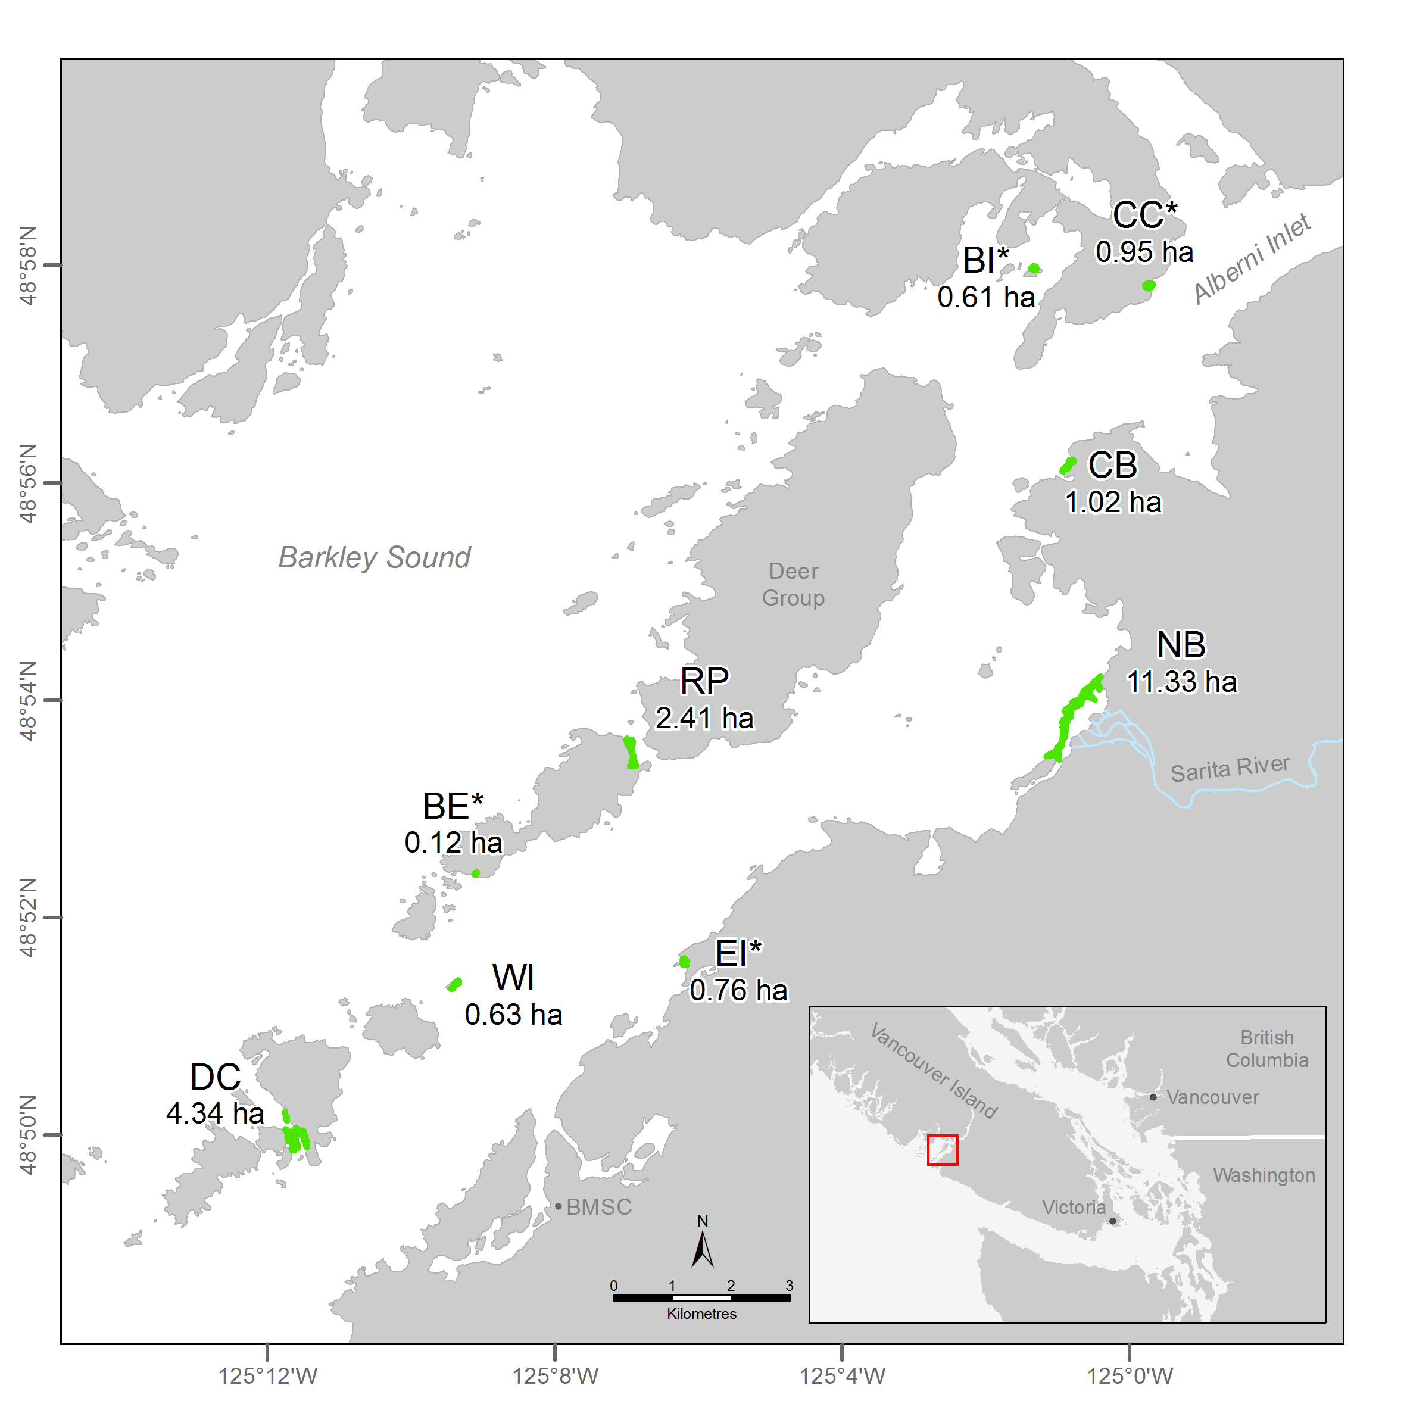

**B.**

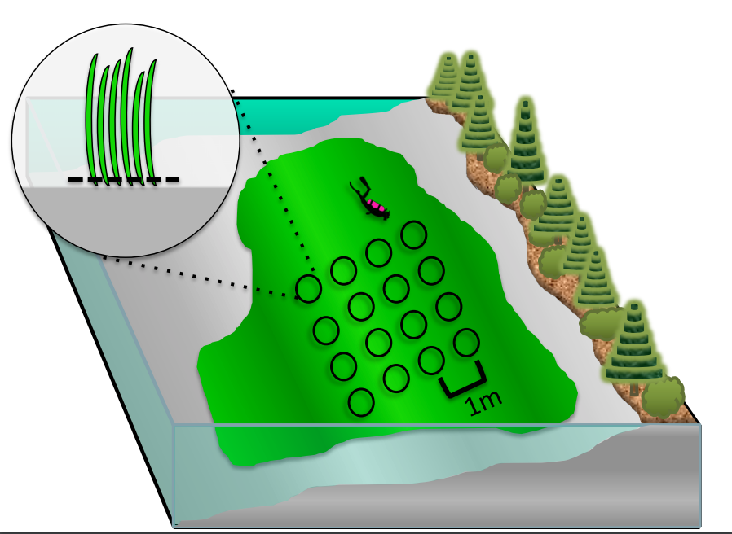

**Figure 2**: Fine-scale epifaunal diversity estimated from sampled plots (0.28 m2, n = 16) in nine eelgrass meadows in Trevor Channel, British Columbia, in midsummer 2012. Asterisks indicate significant differences (P < 0.01) among sites, based on a one-way ANOVA. Sites are arranged left to right in terms distance from a freshwater source, with DC being the most marine and farthest from a freshwater source (Figure 1).

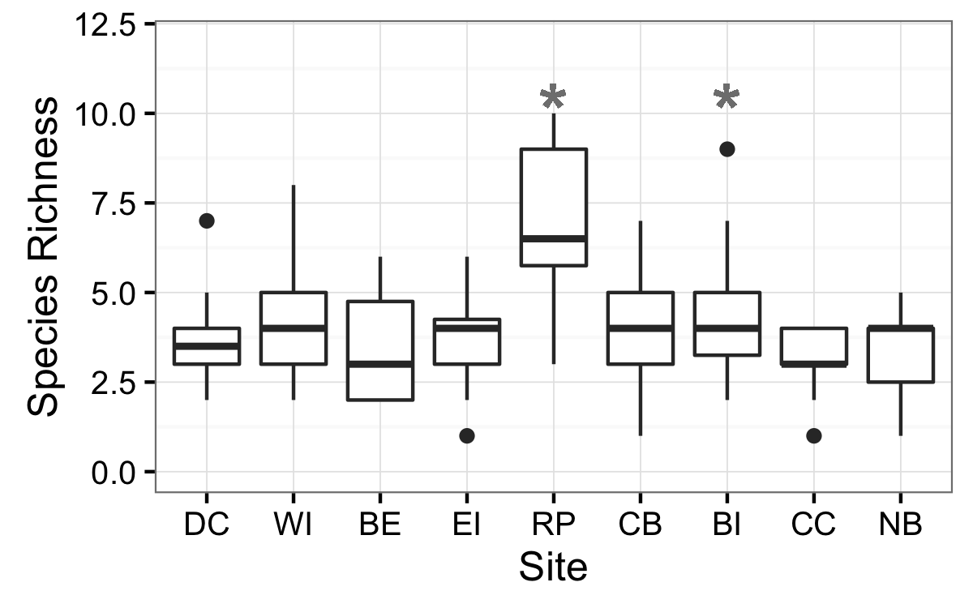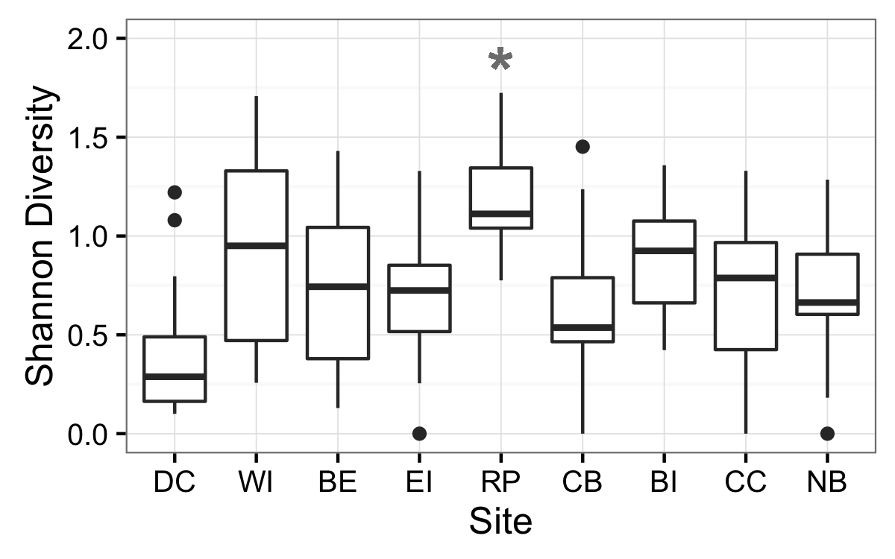

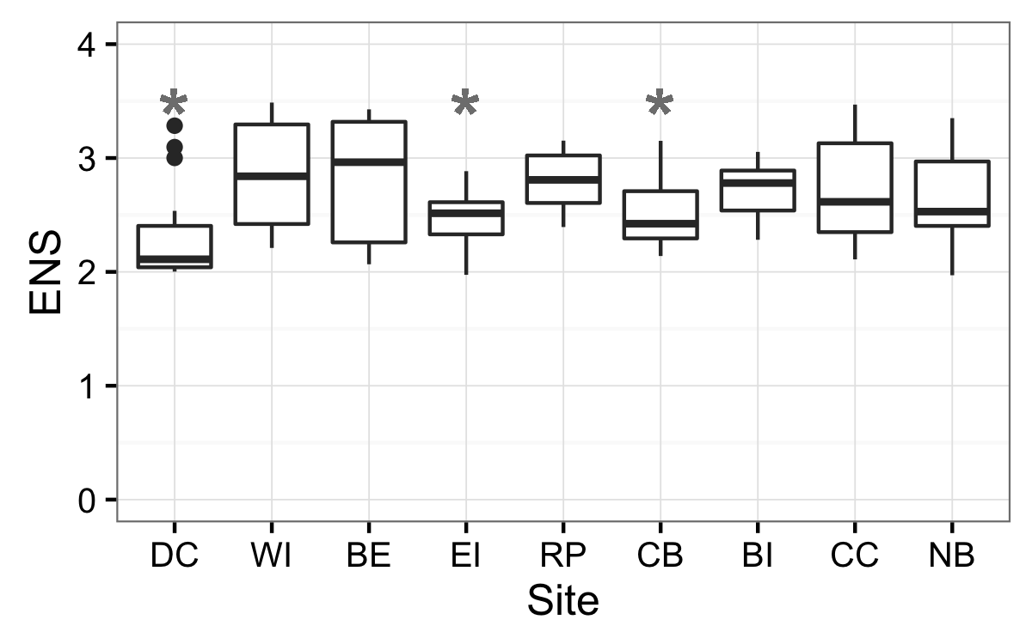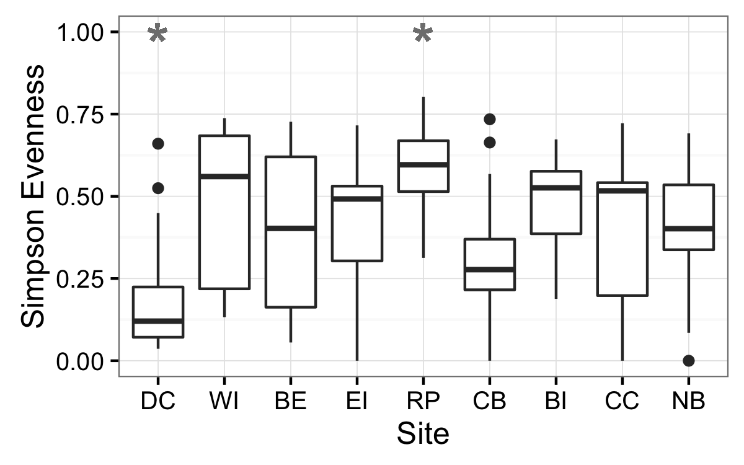

**Figure 3: Temporal trends in species richness (A), rarified richness (B) and beta diversity** (C) within all sites and time periods expressed as mean Bray-Curtis dissimilarity among plots in May (A), June/July (B), and August (C). Site abbreviations as in Table 1.

A) B)

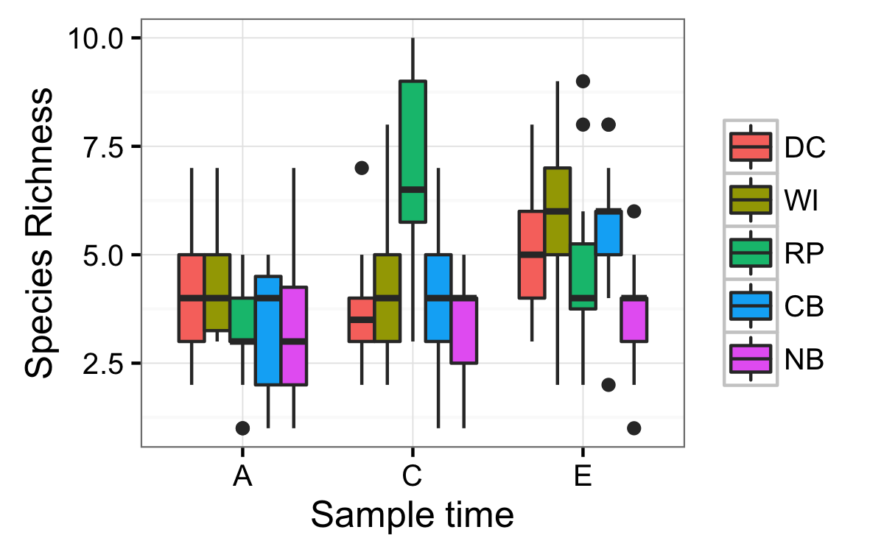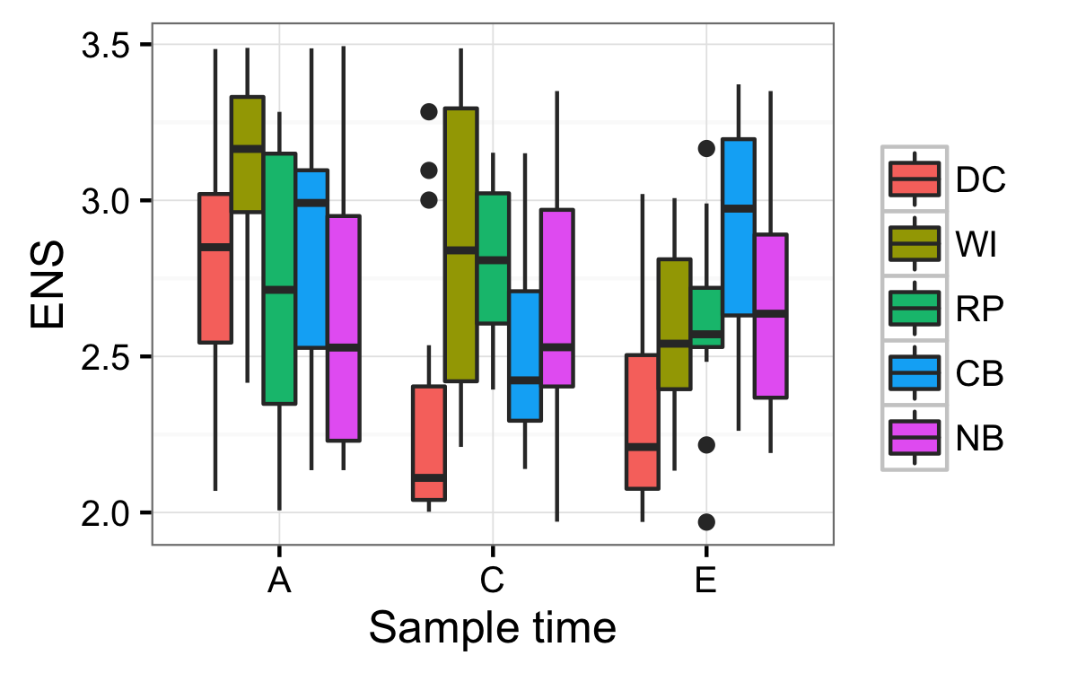

**C)**

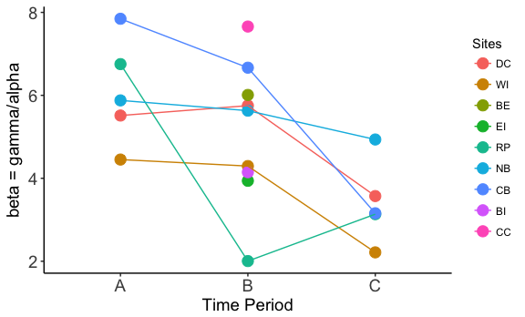

**Figure 4:** **A)** Beta diversity (species composition) within and among meadows varied less than expected. Expected beta diversity (rescaled Raup-Crick Probabilities, BRC) = 0, values approaching 1 show greater dissimilarity than null predictions, values approaching -1 show less dissimilarity than null predictions, with values at 0 being no different from the null predictions. Comparisons show among- and within-site probabilities for 5 (light green) and 9 (dark green) meadows. Comparisons across meadows pool all meadows within each sampling time, comparisons within meadows are pooled within each individual meadow. Box plots embedded with violin plots show median and quartiles, and width of violin plots show kernel probability density of those variables, with wider portions being more likely than narrower portions. **B)** nMDS of community composition and abundance in mid-summer across all sites using Bray-Curtis metric. 2-D stress = 0.23.

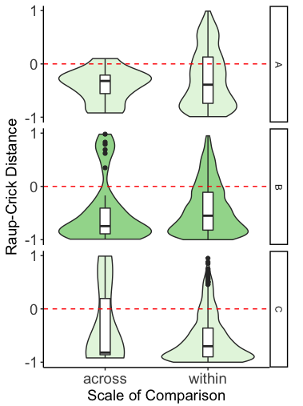

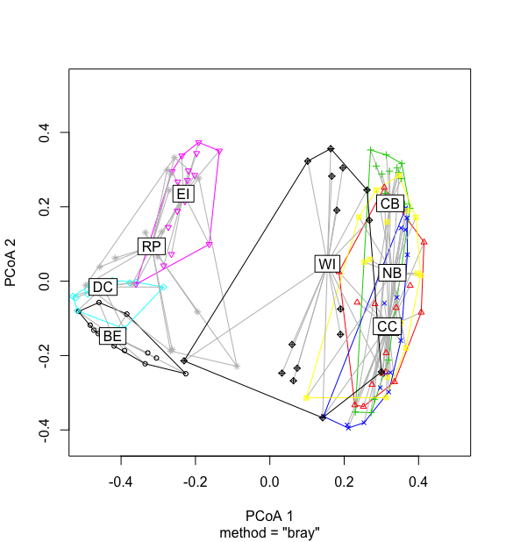

**Appendix table S1**

**Table A1:** Model selection results for plot-level (n = 9) univariate richness indices across nine eelgrass meadows in July 2011.

|  |  |  |  |  |  |  |
| --- | --- | --- | --- | --- | --- | --- |
| **Model** |  | **Df** | **logLik** | **AICc** | **Delta** | **Wt** |
| **alpha** |  |  |  |  |  |  |
| G | Y ~ site | 10 | -234.49 | 490.8 | 0.00 | 1 |
| D | Y ~ 1 | 2 | -262.61 | 529.3 | 38.46 | 0 |
| . | Y ~ area | 3 | -261.96 | 530.1 | 39.26 | 0 |
| B | Y ~ dfw | 3 | -262.25 | 530.7 | 39.83 | 0 |
| A | Y ~ fetch | 3 | -262.60 | 531.4 | 40.54 | 0 |
| C | Y ~ dfw*fetch | 5 | -262.23 | 534.9 | 44.10 | 0 |
| F | Y ~ area*fetch | 5 | -262.35 | 535.2 | 44.33 | 0 |
|  |  |  |  |  |  |  |
| **H’** |  |  |  |  |  |  |
| G | Y ~ site | 10 | -51.28 | 124.4 | 0.00 | 0.999 |
| C | Y ~ dfw*fetch | 5 | -64.17 | 138.8 | 14.39 | 0.001 |
| B | Y ~ dfw | 3 | -67.36 | 140.9 | 16.48 | 0 |
| F | Y ~ area*fetch | 5 | -65.66 | 141.8 | 17.37 | 0 |
| A | Y ~ fetch | 3 | -68.52 | 143.2 | 18.80 | 0 |
| D | Y ~ 1 | 2 | -69.96 | 144.0 | 19.58 | 0 |
| . | Y ~ area | 3 | -69.69 | 145.60 | 21.15 | 0 |
|  |  |  |  |  |  |  |
| **S** |  |  |  |  |  |  |
| G | Y ~ site | 10 | 27.76 | -33.7 | 0.00 | 0.945 |
| C | Y ~ dfw*fetch | 5 | 18.67 | -26.9 | 6.81 | 0.031 |
| F | Y ~ area*fetch | 5 | 17.93 | -25.4 | 8.29 | 0.015 |
| B | Y ~ dfw | 3 | 14.96 | -23.7 | 9.94 | 0.007 |
| A | Y ~ fetch | 3 | 13.35 | -20.5 | 13.16 | 0.001 |
| D | Y ~ 1 | 2 | 11.63 | -19.2 | 14.50 | 0.001 |
| . | Y ~ area | 3 | 12.21 | -18.2 | 15.45 | 0.000 |
|  |  |  |  |  |  |  |
| **ENS** |  |  |  |  |  |  |
| G | Y ~ site | 10 | -52.19 | 126.2 | 0.00 | 0.628 |
| C | Y ~ dfw*fetch | 5 | -59.21 | 128.9 | 2.66 | 0.166 |
| F | Y ~ area*fetch | 5 | -59.78 | 130.0 | 3.80 | 0.094 |
| . | Y ~ area | 3 | -62.56 | 131.3 | 5.07 | 0.050 |
| B | Y ~ dfw | 3 | -63.13 | 132.4 | 6.20 | 0.022 |
| A | Y ~ fetch | 3 | -63.13 | 133.1 | 6.80 | 0.016 |
| D | Y ~ 1 | 2 | -64.88 | 133.9 | 7.62 | 0.011 |

**Table S2:** Mean shoot density and leaf area index (LAI) values with standard error (SE) for patches of eelgrass meadow (0.28m2) sampled in May and August 2012 .

|  |  |  |  |  |  |  |  |  |  |
| --- | --- | --- | --- | --- | --- | --- | --- | --- | --- |
|  | May | | | | August | | | | |
| Site | *Mean Shoot Density* | *SE Shoot Density* | *Mean LAI* | *SE LAI* | | *Mean Shoot Density* | *SE Shoot Density* | *Mean LAI* | *SE LAI* | |
| DC | 12.3 | ±1.3 | 8037 | ±2229 | | 12.7 | ±1.9 | 7902 | ±1213 | |
| WI | 8 | ±3.2 | 3928 | ±1866 | | 7.8 | ±1.8 | 4611 | ±392 | |
| RP | 7.5 | ±2.5 | 2245 | ±5 | | 8 | ±1.8 | 4514 | ±781 | |
| NB | 6.5 | ±0.3 | 1593 | ±476 | | 9.5 | ±0.6 | 4302 | ±1216 | |
| CB | 4 | ±1 | 1903 | ±704 | | 7.3 | ±1.1 | 3562 | ±537 | |

**Table S3:** Mean temperature and salinity values with standard error (SE). need to know how many measurements, over what time periods. add in the position in watershed predictor

|  |  |  |  |  |
| --- | --- | --- | --- | --- |
| Site | *Mean Temperature* | *SE Temperature* | *Mean Salinity* | *SE Salinity* |
| DC | 12.6 | ±0.2 | 25.7 | ±0.6 |
| WI | 13.7 | ±0.2 | 21.7 | ±0.5 |
| RP | 14.1 | ±0.3 | 22.4 | ±0.4 |
| NB | 14.9 | ±0.4 | 16.6 | ±0.5 |
| CB | 14.8 | ±0.5 | 17.3 | ±0.5 |

**FIGURE S1: Raup-Crick dissimilarity within meadows across all sites for May (A), June/July (B), and August (C).**

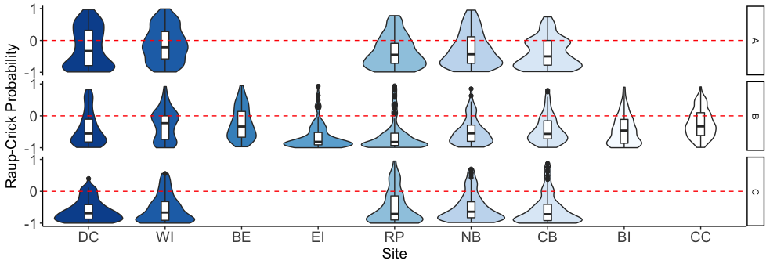

**TABLE 3: Values of beta diversity within each site per time period expressed as gamma/mean alpha, and mean Bray-Curtis dissimilarity**

|  |  |  |  |  |  |  |  |
| --- | --- | --- | --- | --- | --- | --- | --- |
|  |  | Beta (gamma/alpha) | | | Beta (Bray-Curtis) | | |
| Sites |  | A | B | C | A | B | C |
| DC |  | 5.5133 | 5.7523 | 3.5714 | 0.4012 | 0.4041 | 0.2908 |
| WI |  | 4.4519 | 4.2950 | 2.2140 | 0.7253 | 0.6442 | 0.4167 |
| BE |  | NA | 6.0095 | NA | NA | 0.3683 | NA |
| EI |  | NA | 3.9396 | NA | NA | 0.4152 | NA |
| RP |  | 6.7528 | 2.0041 | 3.1348 | 0.3616 | 0.5112 | 0.3318 |
| NB |  | 5.8785 | 5.6306 | 4.9355 | 0.5185 | 0.5407 | 0.4779 |
| CB |  | 7.8462 | 6.6667 | 3.1566 | 0.3915 | 0.6733 | 0.6062 |
| BI |  | NA | 4.1469 | NA | NA | 0.5719 | NA |
| CC |  | NA | 7.6588 | NA | NA | 0.5486 | NA |